ID Token

🧾 What Is an ID Token?
# Source: Chatgpt (GPT-5-Mini) at [1/20/2026]
An ID Token is a digital identity card issued by an identity provider (like Google or Microsoft) that contains information about the authenticated user, such as their name, email, and user ID.
It’s used in OpenID Connect (an identity layer on top of OAuth 2.0).

✅ Simple Definition:
# Source: Chatgpt (GPT-5-Mini) at [1/20/2026]
An ID Token tells an app who the user is — it’s for identification, not access.

🧠 Real-Life Analogy:
# Source: Chatgpt (GPT-5-Mini) at [1/20/2026]
Imagine logging into a website using “Sign in with Google”
- Google gives your app a keycard (access token) to access APIs
- And also gives a digital ID badge (ID token) that says:
"This is Omar, email: omar@example.com"

🔑 Key Features
# Source: Chatgpt (GPT-5-Mini) at [1/20/2026]

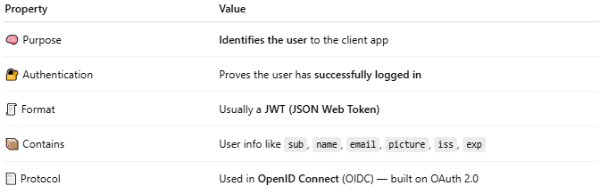

Property | Value
🧠 Purpose | Identifies the user to the client app
🔐 Authentication | Proves the user has successfully logged in
🧾 Format | Usually a JWT (JSON Web Token)
📦 Contains | User info like sub, name, email, picture, iss, exp
📄 Protocol | Used in OpenID Connect (OIDC) — built on OAuth 2.0

🧪 Example Contents (Decoded JWT):
# Source: Chatgpt (GPT-5-Mini) at [1/20/2026]
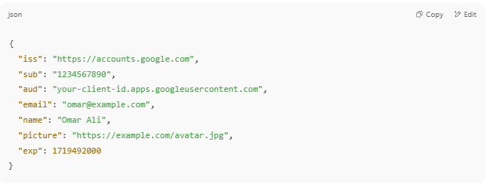

{
"iss": "https://accounts.google.com",
"sub": "1234567890",
"aud": "your-client-id.apps.googleusercontent.com",
"email": "omar@example.com",
"name": "Omar Ali",
"picture": "https://example.com/avatar.jpg",
"exp": 1719492000
}

📌 ID Token vs Access Token
# Source: Chatgpt (GPT-5-Mini) at [1/20/2026]
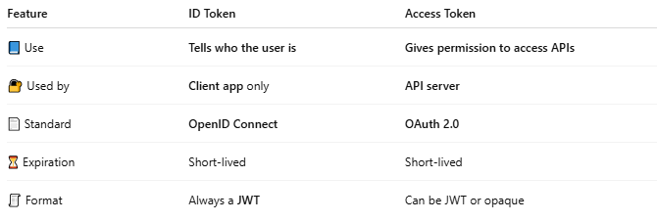

Feature | ID Token | Access Token
📘 Use | Tells who the user is | Gives permission to access APIs
🔐 Used by | Client app only | API server
📄 Standard | OpenID Connect | OAuth 2.0
⏳ Expiration | Short-lived | Short-lived
🧾 Format | Always a JWT | Can be JWT or opaque

👩‍💻 When You Use an ID Token
# Source: Chatgpt (GPT-5-Mini) at [1/20/2026]
- Logging in with Google, Microsoft, Facebook, etc.
- Building SSO (Single Sign-On) systems
- Showing user's name or email after login
- Verifying user's auth status without an API call

⚠️ Security Notes
# Source: Chatgpt (GPT-5-Mini) at [1/20/2026]
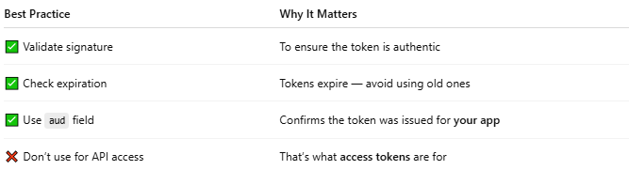

Best Practice | Why It Matters
✅ Validate signature | To ensure the token is authentic
✅ Check expiration | Tokens expire — avoid using old ones
✅ Use aud field | Confirms the token was issued for your app
❌ Don’t use for API access | That’s what access tokens are for

🧩 Summary
# Source: Chatgpt (GPT-5-Mini) at [1/20/2026]
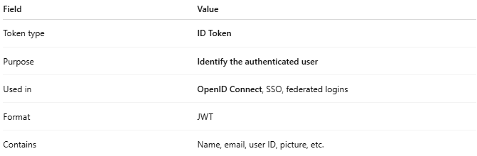

Field | Value
Token type | ID Token
Purpose | Identify the authenticated user
Used in | OpenID Connect, SSO, federated logins
Format | JWT
Contains | Name, email, user ID, picture, etc.

